School Context as at Day Month Year

School Roll | School Attendance | Percentage ASN | PEF Allocation
292 |  | 58% | £ 188,000
SIMD Profile | UNCRC status
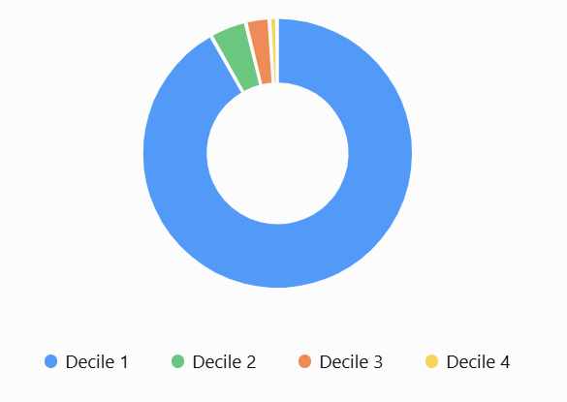 | Gold | 

Cycle of Improvement
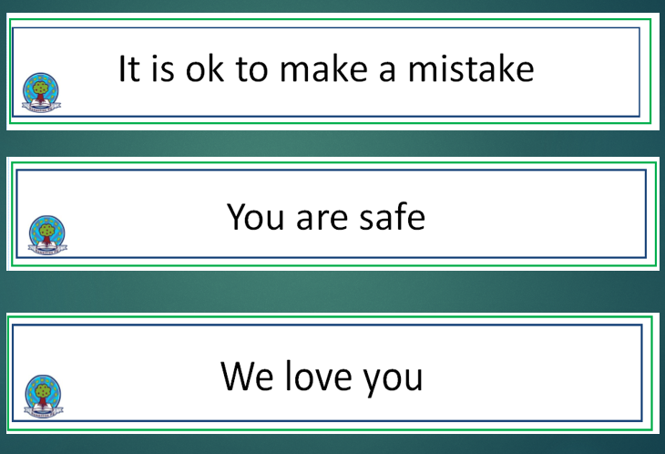
Vision Values and Aims

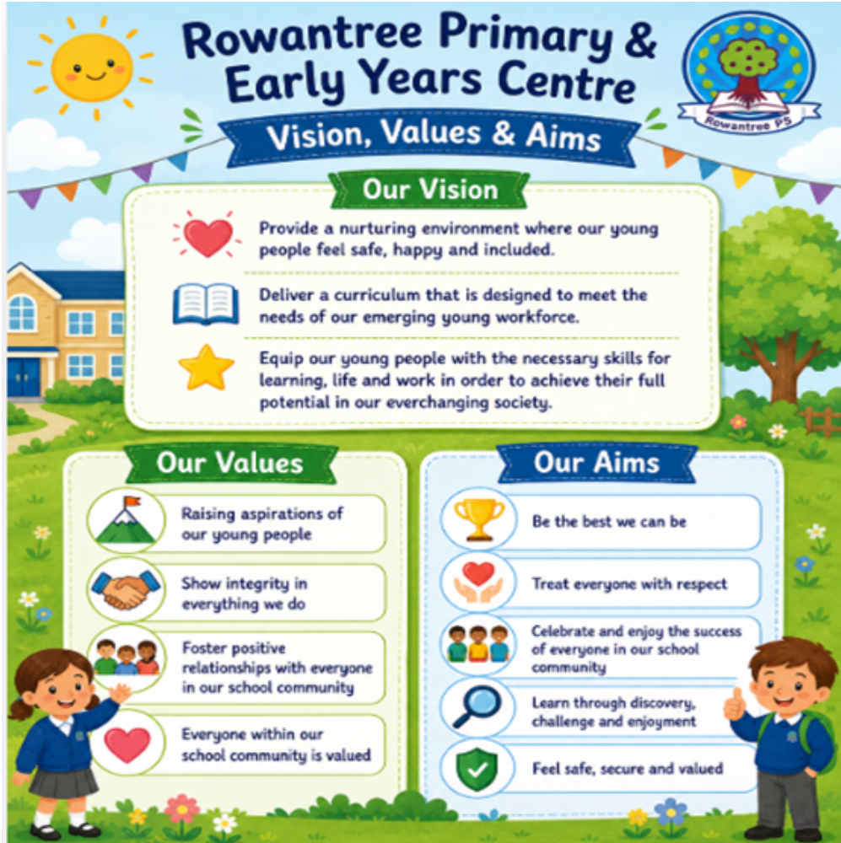


School Priorities 2026-2027

SCHOOL VERSION SIP Priority 1
Specific area for improvement |  |  | To build capacity and develop an understanding of the Curriculum Improvement Cycle.  To upskill staff on the new technical frameworks and prepare for implementation, improvement in Learning and Teaching
Rationale for Improvement  (based on evidence from key stakeholders) |  |  | A national review has led to curriculum reform. Implementation will begin is Session 27/28
Equity Gap (if relevant) |  |  | None
NIF PRIORITIES  Closing the attainment gap between the most and least disadvantaged children and young people  Improvement in attainment, particularly in literacy and numeracy  Choose an item.  Choose an item.  Choose an item. | NIF DRIVERS  Teacher Professionalism  School Leadership  School Improvement  Choose an item.  Choose an item.  Choose an item. |  |  | EDLM PRIORITY    Progress |  | PEF (where applicable)  Intervention for equity & cost  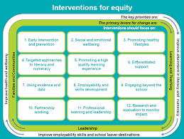  5. Promoting a high quality learning experience  11. Professional learning and leadership  Choose an item. |  | HGIOS QI  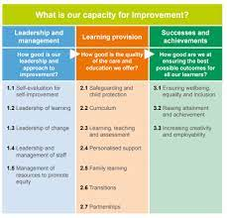  1.3 Leadership of change  2.2 Curriculum
Intended Outcome (impact) |  | Actions required to reach desired outcome |  |  | Measurement & Evidence |  | Who |  | When | Resources
That by June 2027, all teaching staff will understand the curriculum improvement cycle and new technical frameworks and how it impacts their practice.  The school rationale will be updated to prepare for the changes from the CIC and align with emerging pedagogical theories.  Following our Collaborative Improvement Visit we were rated ‘good’ for learning and teaching. This session we will create a ‘Learning Standard’ and a ‘Teacher’s Toolkit’ to move practice forward.  A particular focus will be on ‘challenge’ another area highlighted through the CIV. |  | Staff to engage in on-going professional learning, provided by the local authority, in-line with the timeline given.  All inset days will have a focus on an aspect of the curriculum improvement cycle.  Further twilights and PL sessions will be undertaken to deepen understanding and improve pedagogical approaches.  E-learning modules will be available to consolidate the in-person learning, or for new/returning staff who start mid-session.  Review curriculum rationale and update if required.  Audit of staff confidence, strengths and development needs  Work with staff using 2.3 rubrick to establish features required in a very good/excellent lesson. Use of Standard for Inclusive Practice  Engage with Pedagogy Team to study Schlecty’s Levels of Engagement. |  |  | MS forms used for evaluations and feedback which will inform the local authority of further professional learning that may be required.  Staff knowledge, understanding and confidence will be measured.  Understanding of curricular changes will be evident through planning for learning, teaching and assessment in the current session.  Refreshed curriculum rationale that reflects the current cohort of learners  Peer visits  PSVs  SIPP reciprocal visits  SIPP visits for teaching staff |  | Local authority.  SLT will lead in school.  All staff  Pedagogy Team to deliver training  All staff |  | Session 2026/27 | Timeline, resources and guidance provided by local authority  Ped team  Pedagogy  Toolkit  Guided CLPL

SCHOOL VERSION SIP Priority 2
Specific area for improvement  Rationale |  |  | Progress for All - Current attainment data indicates that writing achievement remains below expected levels, For the 2026/27 cohort, only 50% of P3 learners are currently achieving CfE levels appropriate to their stage. And 41% for P7 While most learners are making progress from their previous level, attainment data highlights a need to increase the proportion of learners achieving expected benchmarks.  In addition, reading attainment at P1 and P4 has shown a decline, and feedback from Standards and Quality Improvement Partnership (SIPP) and Peer Support Visits (PSV) has identified the need to refresh and strengthen approaches to literacy teaching and learning
NIF PRIORITIES  Improvement in attainment, particularly in literacy and numeracy  Closing the attainment gap between the most and least disadvantaged children and young people  Choose an item.  Choose an item.  Choose an item. | NIF DRIVERS  Assessment of Children's Progress  School Improvement  Teacher Professionalism  Choose an item.  Choose an item.  Choose an item. |  |  | EDLM PRIORITY  Progress |  | PEF (where applicable)  Intervention for equity & cost  4. Targeted approaches to literacy and numeracy  Choose an item.  Choose an item. |  | HGIOS QI  2.3 Learning, Teaching and Assessment  3.2 Raising attainment and achievement
Intended Outcome (impact) |  | Actions required to reach desired outcome |  |  | Measurement & Evidence |  | Who |  | When | Resources
To improve writing attainment at all levels  P4(2026/7) = (T): 50.0% (L → T): 84.9%  By June 2027 75% of P7 Learners will have achieved CfE levels appropriate to their stage  P7(2026/7) (T): 41.9% (L → T): 62.8%  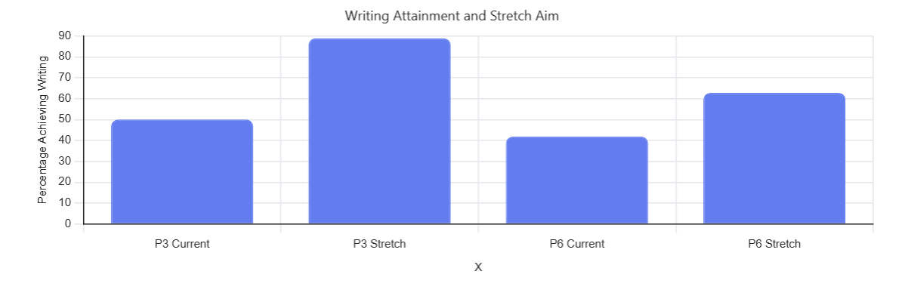  Current reading attainment data at P2 & P3 has taken a dip and feedback from our SIPP/PSVs visits highlights the need to refresh our approaches.  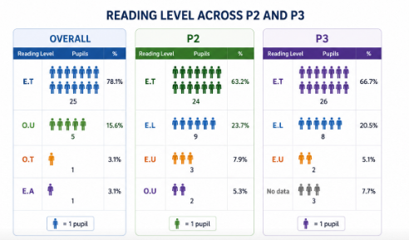 |  | 6 staff now trained in Improving Writing strategy. SLWG to cascade training to whole school.  Impactful timetabling of teaching staff to support small group learning  Continue daily write opportunities across the school. All staff to use pareto charts to track and monitor the success of this targeted intervention.  All class teachers to engage with child version of progression pathway for writing and use this to create learning ladders in class to aid pupil knowledge of expectations and next steps.  Restructure of WTA to incorporate time for planning and delivery and resources.  Revisit the Ruth Miskin Training and buy in a development day. Reregister with the portal in order to have access to strategies and practice models for further CLPL  Continue to upskill reading leaders to support the cascade of information/strategy/lesson structure  Reinvestment in resources |  |  | Pareto charts, measuring impact of intervention.  Analysis of data  Moderation activities  Evidence within written pieces, can pupils transfer knowledge?  Pupil forums – can they articulate where they are in their learning for writing and what their next steps are?  Use of RWI assessments/ teacher judgement  Learning walks and PSVs  Feedback from Ped Team  Feedback from Development Day  How well do we record, analyse and use assessment information to identify development needs for individual learners and specific groups?  How well do we use evidence from tracking meetings, professional dialogue and assessments to measure progress over time and at points of transition? |  | All staff  DHT to coordinate |  | Oct - May | Cold pieces of writing, pareto charts, tools for writing framework  Time from WTA  PEF for resources  Appropriate staffing  WTA time, STEM timetables, STEM resources  Ruth Miskin Portal  Ruth Miskin Development Day  WTA

SCHOOL VERSION SIP Priority 3
Specific area for improvement |  |  | Improve attendance from 89.7% to 95%
Rationale for Improvement  (based on evidence from key stakeholders) |  |  | Historically attendance has been challenging, and school have been part of a CYPIC improvement project. Attendance remains fragile and requires a renewed focus
Equity Gap (if relevant)

NIF PRIORITIES  Closing the attainment gap between the most and least disadvantaged children and young people  Placing the human rights and needs of every child and young person at the centre of education  Choose an item.  Choose an item.  Choose an item. | NIF DRIVERS  Parental Engagement  School Improvement  Choose an item.  Choose an item.  Choose an item.  Choose an item. |  |  | EDLM PRIORITY  Presence |  | PEF (where applicable)  Intervention for equity & cost  10. Partnership working  1. Early Intervention and Prevention  3. Promoting Healthy Lifestyles |  | HGIOS QI  1.5 Management of resources to promote equity  3.1 Enquring wellbeing, equality and inclusion
Intended Outcome (impact) |  | Actions required to reach desired outcome |  |  | Measurement & Evidence |  | Who |  | When | Resources
Increase attendance levels for all – from 89.7% to 94% |  | School inquiry focus SFDW to have a focus on attendance and run groups for parents and pupils around resilience and getting to school. Data used to target priority groups.  Use of KIT bag to support children to get to the root of non-attendance.  Continue to implement our process to ensure we are working in partnership with our families to maintain high levels of attendance for all. Daily phone calls regarding attendance and monthly monitoring of all pupils 90% and below.  Weekly meetings with SFDW to discuss high level messages from Attendance monitoring and group work. Tight focus on attendance and early intervention. Teachers to flag concerns/pattern via cause for concern forms.  Questionnaire to parents in term 1 – gather evidence about barriers to attendance. Use this information to establish themes for support groups run by Attendance Team and linked to CAMHS portal  Targeted support utilising DUSC/SFDW and J Robbins in the mornings (breakfast meets/target setting) identifying children who are high priority and need a ‘hook’ to get them into school. |  |  | Attendance data to be reviewed each month, database to be used to track trends.  Attendance database  Parent/Carer questionnaires  Use Glasgow Motivational each term and Wellbeing Toolkit for each child, how do they view themselves as a learner?  Observations/discussions  PDSA model for targeted interventions with parents and pupils.  Run chart of attendance figures  Monthly run chart.  Individual target setting/Class attendance on display  How well do we ensure that all children feel safe, healthy, achieving, nurtured, active, respected, responsible and included?  How effectively do we allocate resources to sustain improvement priorities? |  | SFDW  Joanie Robbins  Linlathen Family Support Officer |  | Session 26/27 | Data from City, spreadsheet  SFDW  Time, spreadsheet, cause for concerns  Parent Survey  Questionnaires  Glasgow toolkit  Space for groups KIT bags

Summary of PEF Spend
Area of expenditure | Details | Reference to Plan | Budgeted allocated
Teaching staff | 0.1 | As per SIP | £17,142
Support staff | SFDW | As per SIP | £44,453
Enhance digital infrastructure | 1 class set of laptops, Lego kits x2 |  | £30,000
Transport | Transport for enrichment activities |  | £4000
CLPL | Reading Development Day | As per SIP | £1000
Resources | Reading Portal, Reading resources, Accessit Library, Outdoor Education resources, | As per SIP | £15,000
Payments to other bodies | Joanie Robbins, DUSC, The Yard, | As per SIP | £50,000
Other (please specify) | LSG children – alternative curriculum activities  Residential Trip |  | £2500  £5000

SCHOOL VERSION Priority 4 To strengthen our inclusive school culture by promoting respect, challenging discrimination, and developing positive relationships so that every child feels safe, respected and valued.
Further PEF Interventions |  |  | DUSC, Joanie Robbins, Linlathin Fairness initiative
Equity Gap (if relevant) |  |  | Some children and young people, do not experience the same levels of safety, inclusion, respect and belonging, with incidents of racism and bullying disproportionately affecting some groups of children and young people.
NIF PRIORITIES  Improvement in children and young people's health and wellbeing  Placing the human rights and needs of every child and young person at the centre of education  Choose an item.  Choose an item.  Choose an item. | NIF DRIVERS  School Leadership  Teacher Professionalism  Parental Engagement  School Improvement  Choose an item.  Choose an item. |  |  | EDLM PRIORITY  Participation |  | PEF (where applicable)  Intervention for equity & cost  1. Early Intervention and Prevention  2. Social and Emotional Wellbeing  9. Engaging beyond the school |  | HGIOS QI  2.1 Safeguarding and child protection  3.1 Enquring wellbeing, equality and inclusion
Intended Outcome (impact) |  | Actions required to reach desired outcome |  |  | Measurement & Evidence |  | Who |  | When | Resources
Linlathen is a diverse community with many residents, organisations and community groups working positively to promote inclusion, fairness and community cohesion.  Residents have expressed anxieties linked to pressures on local services, housing availability and community resources. These views can contribute to negative perceptions, misconceptions and, in some cases, prejudice towards newcomers.  We want to promote respect for different cultures and lived experiences, while challenging racism, discrimination and misinformation.  To strengthen our inclusive school culture by proactively addressing racism, prejudice and gender-based violence through education, early intervention and positive role models  We aim to ensure all children feel safe, respected and loved, while developing the knowledge, skills and attitudes needed to build healthy relationships and challenge discrimination.  Creation of Poverty Action group and CLPL for staff following DHTs involvement with Education Scotland’s Poverty Equity Group.  We want to see recorded incidents of bullying and racism at 0.  Currently 6 reports on SEEMIS |  | Embed learning about equality, diversity, anti-racism and respectful relationships across the curriculum.  Deliver age-appropriate learning experiences that develop children's understanding of consent, respect, inclusion and challenging stereotypes.  Utilise support workers from our partner DUSC to deliver targeted programmes and mentoring that promote positive masculinity, teamwork, respect and healthy relationships.  Strengthen pupil voice through opportunities for children to discuss issues of fairness, discrimination and inclusion.  Provide professional learning for staff to build confidence in recognising and responding to incidents of racism, prejudice and gender-based behaviours.  Engage families and community partners in promoting shared values of respect, equality and inclusion. |  |  | Records of racist incidents and prejudice-based incidents.  Behaviour and bullying incident data. We would anticipate an initial increase with children recognising the signs, but the expectation is that this would reduce the year.  Attendance and exclusion data where relevant.  Staff surveys evaluating confidence and knowledge before and after professional learning.  Feedback from professional learning sessions.  Staff reflections and evaluations.  Evaluations from football club support workers and partner agencies.  Parent/carer questionnaires and consultation feedback.  Evidence of family engagement in workshops or awareness events.  How well do we ensure that all children feel safe, healthy, achieving, nurtured, active, respected, responsible and included? |  | All staff  All children  Partner Agencies  SFDW |  | Session 26/27 | Education Scotland Modules  ‘Mitigating the Impact of Poverty on Scotland’s Children and Young People
Progress
This box should be used to note progress throughout the session

Driving Excellence and Equity
Standards and Quality Report



Name of school Rowantree Primary School & Early Years Centre

Date of report 1/6/2026

Together, we lead a school committed to high expectations, a positive ethos and an inclusive, nurturing culture for our children, families and staff. We are proud to have been the first school in Dundee to achieve the Gold award for UNCRC. This session we received Digital acclaim in the following:

Context and School Profile
School Community
Total roll (including EYC): 335
Primary roll: 291
SIMD profile:
SIMD 1: 86%
SIMD 2: 3%
SIMD 3 up: 11% children in this bracket are here and at locality school
Free School Meal entitlement: 85%
Our PEF allocation is £188,000
· Our ASN profile is 58%
Our children bring curiosity, warmth and talk to us about their love of our school. They tell us they feel safe, cared for and supported as demonstrated in improved results of wellbeing surveys and pupil voice groups.
We have strong relationship with our Rowantree Early Years Centre supporting robust transition and shared pedagogy, particularly in play-based learning at Early Level. The last Care Inspectorate visit left us with scores of 5s in all areas.

Vision, Values and Culture
· Be Ready
· Be Safe
· Show Respect
These are embedded daily across classrooms, assemblies and whole-school routines. Our School and Playground Charters (developed with children) further strengthen rights-based approaches.

Another 3 statements that are our mantra and we use these in restorative conversations:
Are: It’s ok to make a mistake, You are safe and You are loved.

SIP priority 1 -
Progress including quantitative data to measure progress
Significant progress has been made towards this priority during the session. A new pedagogical approach to writing was introduced in P1, P4 and P6, with a clear focus on improving learner engagement, writing quality and attainment outcomes. Staff worked collaboratively to implement the approach consistently, using agreed methodologies and assessment measures to track progress.
Analysis of assessment data demonstrates a positive impact on learner outcomes. Writing attainment has increased was in P1, and in P6 over the course of the intervention. Learners demonstrated increased confidence, greater independence in writing tasks and improved ability to apply writing skills across a range of contexts.
A key factor in the success of this work has been the investment in professional learning. Additional staff received training in the new approach, increasing capacity across the school and ensuring greater consistency in delivery. Staff reported increased confidence in teaching writing and in using data to inform next steps for learning.
The use of Pareto charts has strengthened our approach to improvement methodology. By identifying the most common barriers to writing success, staff were able to target interventions more effectively and focus improvement efforts where they would have the greatest impact. This data-informed approach enabled more responsive teaching and supported continuous evaluation of progress.
Whole-class visual displays of progress have also contributed positively to learner engagement. These displays have helped pupils to understand their learning journey, celebrate achievements and identify next steps. Learners have shown increased ownership of their progress and greater motivation to improve their writing outcomes.

Next steps - Building on the success of the targeted intervention, we will implement the writing pedagogy as a whole-school approach to ensure consistency, progression and high-quality learning experiences across all stages. Staff will continue to engage in professional learning, moderation and collaborative planning to strengthen practice and maintain fidelity to the approach. We will further develop the use of data, including Pareto analysis and visual progress tracking, to identify barriers, monitor impact and support all learners to achieve their full potential in writing.

SIP priority 2 -
Progress including quantitative data to measure progress
Digital Health & Wellbeing, Equitable Coding Award – achieved
Attendance
School attendance showed a positive improvement initially, increasing from 86%-89% following the implementation of targeted support strategies. These interventions included access to Breakfast Club, Out of School Club provision, soft starts, easy ends, and ongoing whole-family support from the School and Family Development Worker. These measures helped reduce barriers to attendance, improved engagement with school, and supported the family in establishing more consistent routines.
Despite this progress, overall attendance has been impacted by family holidays taken during term time, resulting in a reduction in attendance figures. While the school and partner agencies have worked collaboratively with the family to promote the importance of regular attendance, periods of authorised and unauthorised absence linked to holidays have affected the sustainability of the initial gains.

Next steps –
To further improve attendance, the school will implement a range of targeted strategies aimed at identifying and addressing barriers faced by families. Parent surveys will be distributed to gather feedback and establish common themes affecting attendance. Findings will inform future planning and support provision.
Referrals to the School and Family Development Worker will continue for families requiring additional support, with a particular focus on issues relating to finance, housing, wellbeing, and family circumstances. Where common themes emerge, the school will establish family support groups to provide practical advice, peer support, and access to relevant services.
Communication with families will be strengthened through renewed attendance-focused phone calls and regular check-ins to identify concerns at an early stage. Parent information evenings will include a focus on attendance data and the impact of attendance on children's outcomes, helping to raise awareness and promote positive attendance habits.
Attendance statistics will be made more visible throughout the school through the use of visual displays and posters in the school foyer and classrooms. Whole-school attendance figures and key messages will also be shared regularly during assemblies to celebrate success, reinforce expectations, and encourage a culture of high attendance across the school community.

SIP priority 3 -
Pedagogical approaches to Numeracy
The focus on conceptual understanding has established a stronger foundation for numeracy learning across the school and has contributed to improved attainment and achievement in mathematics. Continued professional learning and moderation activities will support the sustainability of these improvements and ensure consistent high-quality practice across all stages.

As a result of this professional learning, staff have increased their confidence and consistency in delivering high-quality numeracy experiences that promote deeper mathematical understanding rather than procedural fluency alone. Classroom observations, professional dialogue, and learning walks have demonstrated greater use of concrete materials, mathematical discussion, problem-solving opportunities, and approaches that support children's conceptual understanding of number.
Analysis of attainment data indicates that these improvements in pedagogy have had a positive impact on learner outcomes.

Next steps
A renewed focus will be placed on ensuring consistency in high-quality numeracy pedagogy across all classes, with regular learning walks, peer observations, and professional dialogue used to evaluate impact and identify areas for further development. Staff will continue to engage in moderation activities to strengthen professional judgement and ensure a shared understanding of standards and progression in numeracy.
The school will extend the focus on conceptual understanding into other areas of mathematics, including algebraic thinking, measurement, and data handling, ensuring that learners can apply mathematical concepts across a range of contexts. Assessment data will continue to be analysed at key stages to monitor progress, identify attainment gaps, and inform targeted interventions.
Pupil voice will be gathered to evaluate learners' confidence, engagement, and understanding in numeracy, and parents will be supported to develop their understanding of current approaches to mathematics through information sessions and home learning resources. This will help strengthen partnerships between home and school and further support children's progress in numeracy.

Improvement in Literacy attainment (include data over time for P1,4, and P7 and comment specifically on how you are closing the poverty related attainment gap 200 words max)

Be sure to capture where current p4s were in P1 and where current P7s were in P4 and P1
Share any good news stories here re attainment in literacy in specific year groups following targeted interventions
Include any improvements related to the work in SIG/EDLM

Literacy | 19/20 (current P7) | 21/22 | 22/23 | 23/24 | 24/25 | 25/26
P1 | 74 | 65 | 66 | 56 | 68 | 74
P4 | 73 | 37 | 48 | 65 | 76 | 59
P7 | 57 | 60 | 67 | 58 | 63 | 76

Attainment senior phase –
1 or more awards at SCQF level 4 or better (ASN)
1 or more awards at SCQF level 5 or better (SIMD)
1 or more awards at SCQF level 6 or better (SIMD)

Improvement in Numeracy attainment (include data over time for P1,4, and P7 and comment specifically on how you are closing the poverty related attainment gap 200 words max)

Be sure to capture where current p4s were in P1 and where current P7s were in P4 and P1
Share any good news stories here re attainment in literacy in specific year groups following targeted interventions
Include any improvements related to the work in SIG/EDLM

Numeracy | 19/20 (current P7) | 21/22 | 22/23 | 23/24 | 24/25 | 25/26
P1 | 74 | 65 | 66 | 56 | 68 | 91
P4 | 73 | 37 | 48 | 65 | 76 | 66
P7 | 57 | 60 | 67 | 58 | 63 | 72

Attainment senior phase –
1 or more awards at SCQF level 4 or better (ASN)
1 or more awards at SCQF level 5 or better (SIMD)
1 or more awards at SCQF level 6 or better (SIMD)

Improvement in HWB and positive impact of opportunities for wider achievement (200 words max)

Improving Health and Wellbeing has continued to be a key priority across the school, with a strong focus on promoting positive physical, emotional and social wellbeing for all pupils. Our children have benefited from a wide range of extra-curricular clubs which have supported teamwork, confidence, resilience and active lifestyles. 55% of our children access clubs through Active Schools which does not include our Glee Choir of 40 children and various art & craft clubs.

This year we have seen 8 families join the Family book club event on a Monday night where they have enjoyed time in the library, supported by our School and Family development worker and met with an author. This club includes a hot meal and is regularly attended by an author or an artist.

Children have also had access to free fruit and morning toast, helping to encourage healthy eating habits and improve awareness of making positive lifestyle choices. Opportunities to participate in trips and visits within the local community have enriched children’s learning experiences, developed social skills and strengthened connections with the wider community. These experiences have contributed positively to the children’s engagement, wellbeing and inclusion across the school. Violent incidents have gone from 300 to under 100 over the session. Term 4 has seen this number drop to 15 VIs.

Wider achievement celebrations take place during assembly with parents sharing their children’s success through a link on Seesaw and recorded in Pupil Tracking

Evaluative comments on attendance and exclusion data (200 words max)

We have 0 exclusions to date.

Attendance has risen from 23/24 but this remains fragile. The team continue to work with families to support attendance and regular Care & Welfare meetings are held with SFDW and SLT.
23/24 86%
24/25 89%
25/26 89%

(See SIP priority above)

Evaluation of and the impact of PEF, interventions to tackle inequity and COSD (200 words max)

PEF report 

Any additional information

HGIOS? Quality Indicators | School Grade | HMI grade (in the last 4 years) | Nursery grade | Nursery HMI grade (in last 4 years) | Most recent care inspectorate grade
QI 1.3: Leadership of change | 4 | n/a | 4 | n/a | 5
QI 2.3: Learning, teaching, and assessment | 4 | n/a | 4 | n/a | 5
QI 3.1: Ensuring wellbeing, equity, and inclusion | 5 | n/a | 5 | n/a | 5
QI 3.2: Raising attainment and achievement  QI 3.2: Securing progress (nursery) | 4 | n/a | 4 | n/a | 5
Additional QI of school/nursery’s choice e.g. 2.7 partnerships | 5 | n/a | 5 | n/a | 5

Click here to link to next year’s SIP and SQR (you need to create a hyperlink to your next plan)

